
Data Structures and
Algorithms (23CSE203)
LAB MANUAL
Submitted By:
Name | K MADHU SATYAKUMAR
Roll No | AV.SC.U4CSE25118
Year/Sem/Section | 2nd YEAR/SEM-3/CSE-B
Date of Submission
Submitted To:
Name | Dr. Raj Kumar Batchu
Department | CSE
Designation | Assistant Professor(Sl. Gr) , School of Computing

MARKS

S.No | TITLE | PAGE NO | REMARKS
1. | 1(A) Aim:  A rocket launch system displays countdown before launch . Using recursion write python program to display countdown to 1 followed by launch.  1(B) Aim:  Write a python program to calculate compound interest by taking user input.  1(C) Aim:  HR Department stores Employee Id’s in a list develop a recursive program in python to search for a given employee Id in the list.  1(D) Aim:  Develop a python program to print 1st n terms of Fibonacci series.  1(E) Aim:  Develop a python program to calculate factorial of a given number. | 2-10
2. | 2(A) Aim:  Write a python program to implement linear search.  2(B)(i) Aim: Write a python program to implement binary search with sorted array as input.  (ii) Aim: Write a python program to implement binary search with unsorted array as input. | 10-16
3. | 3(A) Aim:  Write a python program to apply insertion sort where input elements are taken from the user .  3(B) Aim:  Write a python program to apply bubble sort where input elements are taken from the user .  3(C) Aim:  Write a python program to apply selection sort where input elements are taken from the user . | 16-22
LAB-1:
1.)Basic Programs Using Recursions :
A.) Aim: A rocket launch system displays countdown before launch . Using recursion write python program to display countdown to 1 followed by launch.
Program:
def rocket_countdown(n):
if n == 0:
print("LAUNCHED! ")
return

print(n)

rocket_countdown(n - 1)

start_num = int(input("Enter starting countdown number: "))

print("\n--- Starting Countdown ---")
rocket_countdown(start_num)

Output(+Ve Case):
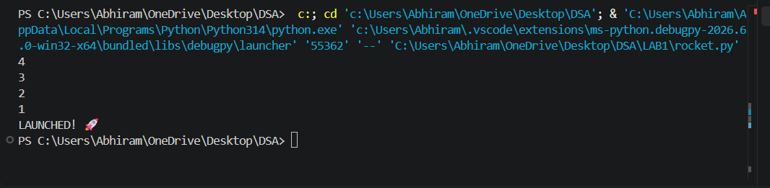
Output(-Ve Case):
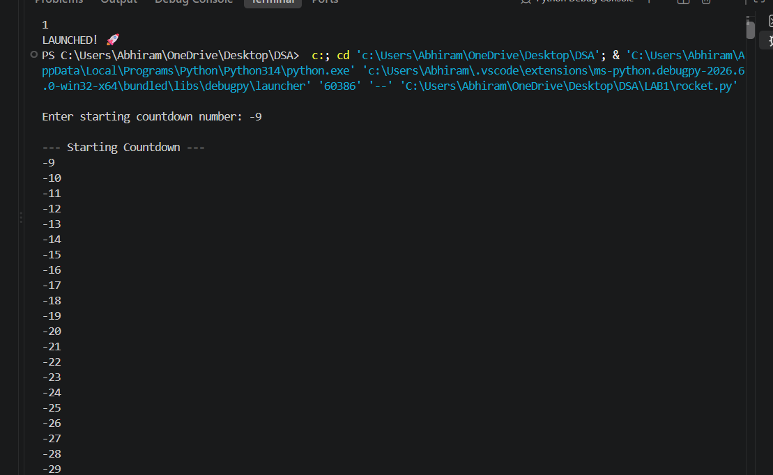
Explanation : This negative scenario has occurred due to infinite recursion . Countdown should never start from -ve integers as decrement will lead to negative infinity and the program crashes.

B.) Aim: Write a python program to calculate compound interest by taking user input.
Program:
def C_Int(p,n,r,t):
decimal_rate = r/100
total_amount = p*(1+decimal_rate/n)**(n*t)
interest_earned = total_amount - p
return total_amount, interest_earned

p = int(input("Enter the principal amount (₹) : "))
n = int(input("Times compounded per year : "))
r = float(input("Enter the annual interest rate (%) : "))
t = float(input("Enter the number of years : "))

final_balance, pure_interest = C_Int(p, n, r, t)

print("\n--- Financial Breakdown ---")
print(f"Interest Earned: ₹{pure_interest:.2f}")
print(f"Total Balance: ₹{final_balance:.2f}")

Output(+Ve Case):
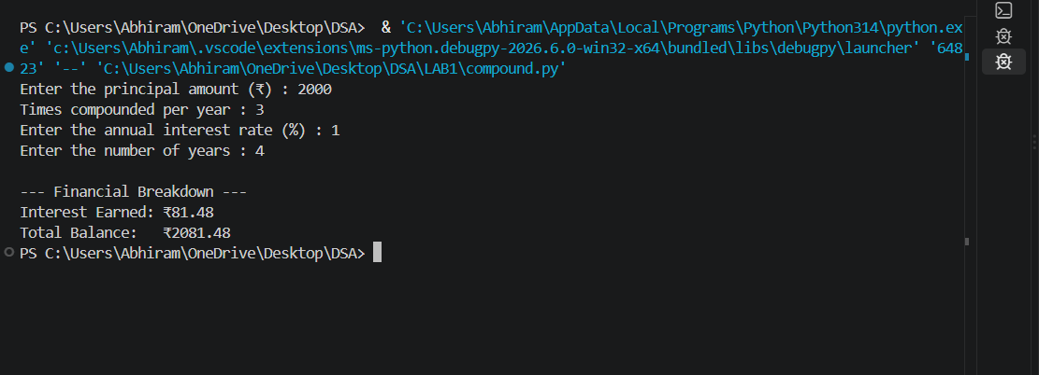
Output(-Ve Case):
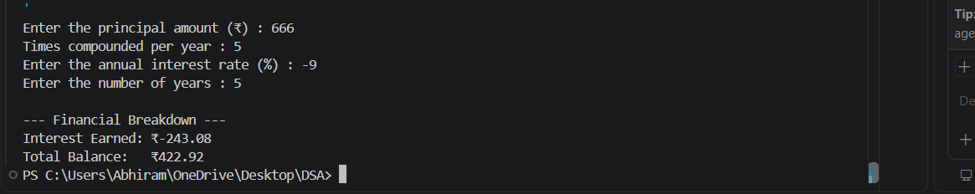
Explanation : Financial values such as Principal Amount, Rate of interest , Number of years should never be allowed to be negative this program projects a just output if and only if all of the input values are +ve.

C.) Aim: HR Department stores Employee Id’s in a list develop a recursive program in python to search for a given employee Id in the list.
Program:
def rec_bin_search(arr,key,low,high):
if low > high :
return -1
mid = (low+high)//2

if arr[mid] == key:
return mid
elif key < arr[mid]:
return rec_bin_search(arr,key,low,mid-1)
else:
return rec_bin_search(arr,key,mid+1,high)

Emp_Ids = [1002, 1005, 1012, 1025, 1040, 1077, 1100]
search_id = int(input("Enter Employee ID to search: "))

result_index = rec_bin_search(Emp_Ids,search_id,0,(len(Emp_Ids)-1))
if result_index != -1:
print(f"Employee ID {search_id} found at index {result_index}.")
else:
print(f"Employee ID {search_id} not found in the HR system.")

Output(+Ve Case):
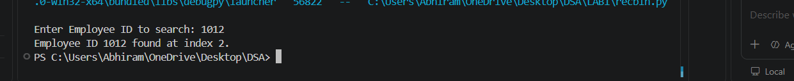
Output(-Ve Case):

Explanation : Binary Search only works when the given array is in sorted order. Although the element 1012 Exists in the lists the program has returned that it doesn’t which is an error.

D.) Aim: Develop a python program to print 1st n terms of Fibonacci series.
Program:
def fib(n):
if(n < 0):
print("Please enter a +ve number")
return None
if (n == 0 or n == 1):
return n
else:
return fib(n-1)+fib(n-2)

n = int(input("Enter the number : "))
for i in range (n+1):
print(f"{fib(i)}",end = " ")

Output(+Ve Case):
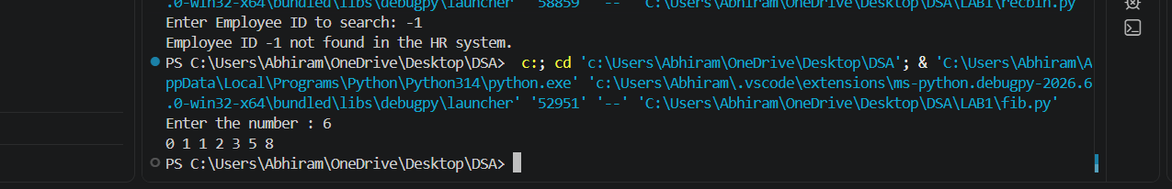
Output(-Ve Case):
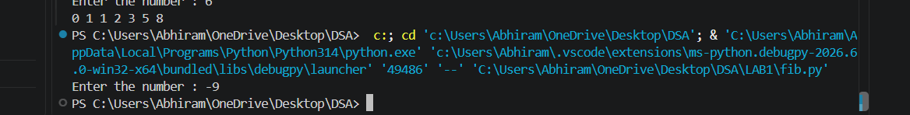
Explanation : a standard Fibonacci function should not accept negative numbers because negative inputs break the standard forward-sum logic and cause infinite loops.
E.) Aim: Develop a python program to calculate factorial of a given number.
Program:
def fac (n):
if n < 0 :
print("Please aenter a +ve number")
return None
if n == 0 or n == 1:
return 1
else:
return n*fac(n-1)

n = int(input("Enter a number : "))
print(f"The Factorial of {n} is {fac(n)}")

Output(+Ve Case):
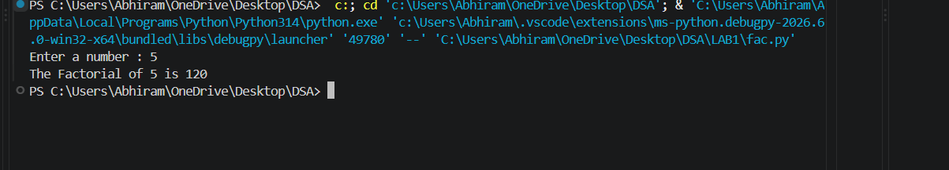
Output(-Ve Case):
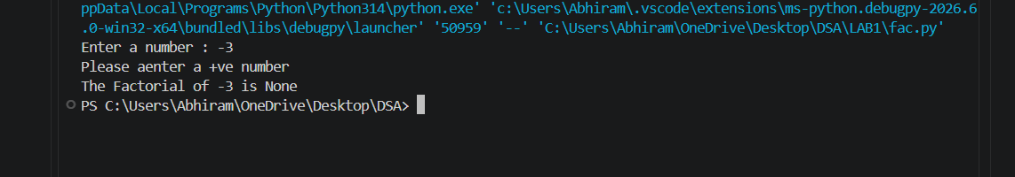
Explanation : The given Fibonacci sequence generator accepts only integer values giving values other than the integer data type such as float or special characters results in this type of Value Error.
LAB-2:
1.)Applying Searching Algorithms :
A.) Aim: Write a python program to implement linear search.
Program:
def lin_search(arr, key):
for i in range(len(arr)):
if arr[i] == key:
print(f"{key} at index {i}")
return
print(f"{key} not found")

n = int(input("Enter the number of elements: "))

arr = []

print("Enter elements:")
for i in range(n):
arr.append(int(input()))

key = int(input("Enter the key: "))

result = lin_search(arr, key)

Output(+Ve Case):
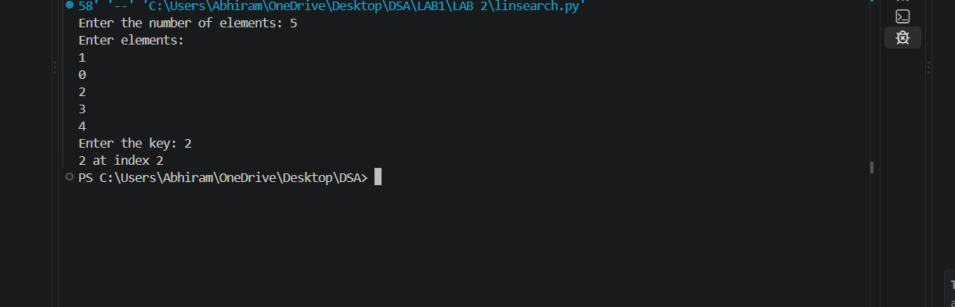
Output(-Ve Case):
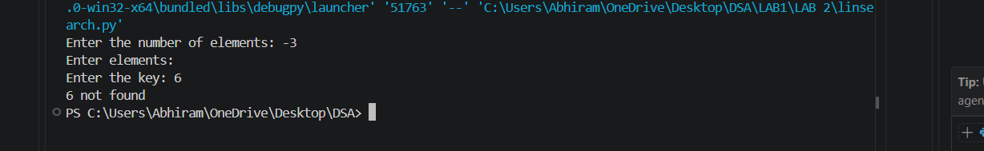
Explanation : The number of input elements should never be negative . In this case since input elements are -5 the program doesn’t allow me to enter any input elements nor is able to check the key given by the user.

B.)(i) Aim: Write a python program to implement binary search with sorted array as input.
Program:
def bin_search(arr,key):
low = 0
high = len(arr) - 1
while low <= high:
mid = (high+low)//2
if arr[mid] == key:
return mid
elif arr[mid] < key:
low = mid+1
else:
high = mid-1
return -1

n = int(input("Enter the number of elements: "))

arr = []

print("Enter elements:")
for i in range(n):
arr.append(int(input()))

key = int(input("Enter the key: "))

result = bin_search(arr, key)
if result!=-1:
print(f"Element found at index {result}")
else:
print("Element not found")
Output(+Ve Case):
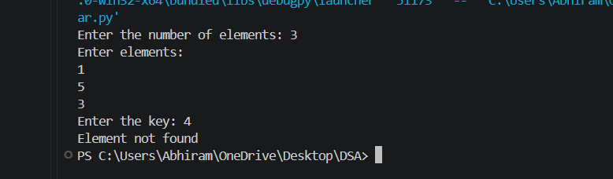
Output(-Ve Case):
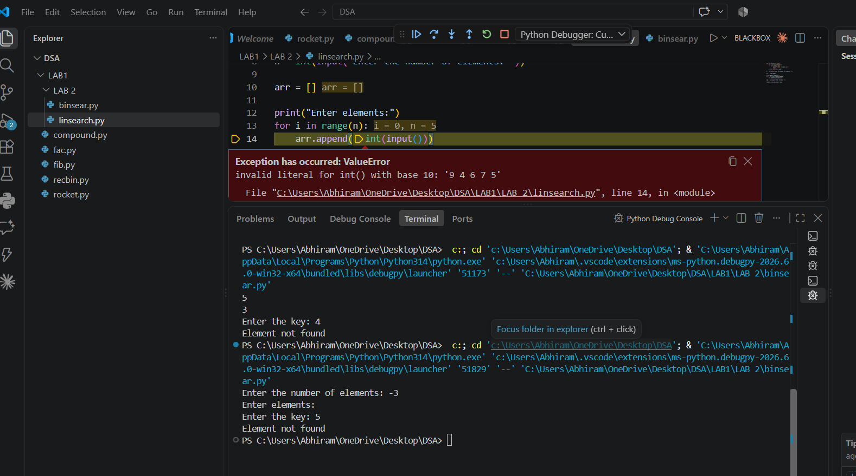
Explanation : The number of input elements should never be negative . In this case since input elements are -5 the program doesn’t allow me to enter any input elements nor is able to check the key given by the user.
(ii) Aim: Write a python program to implement binary search with unsorted array as input.
Program:
def bin_search(arr,key):
low = 0
high = len(arr) - 1
while low <= high:
mid = (high+low)//2
if arr[mid] == key:
return mid
elif arr[mid] < key:
low = mid+1
else:
high = mid-1
return -1

n = int(input("Enter the number of elements: "))

arr = []

print("Enter elements:")
for i in range(n):
arr.append(int(input()))
if arr == sorted(arr):
print("\n input list is already sorted")
else:
print("input list is not sorted")
print("sorting list....")
arr.sort()
print(f"Sorted List : {arr}")

key = int(input("Enter the key: "))

result = bin_search(arr, key)
if result!=-1:
print(f"Element found at index {result}")
else:
print("Element not found")

Output(+Ve Case):
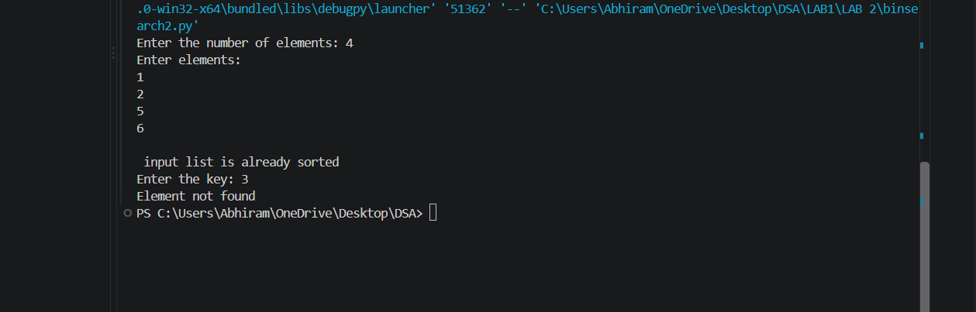

Output(-Ve Case):
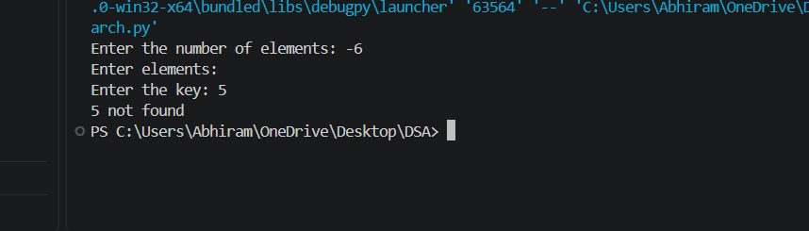

Explanation : The given Binary Search accepts only integer values giving values other than the integer data type such as float or special characters results in this type of Value Error.

LAB-3:
1.)Applying Sorting Algorithms :
A.) Aim: Write a python program to apply bubble sort where input elements are taken from the user .
Program:
def bubble_sort(arr):
n = len(arr)
for i in range(n-1):
for j in range(n-i-1):
if arr[j] > arr[j+1]:
arr[j],arr[j+1] = arr[j+1],arr[j]
return arr

n = int(input("Enter the number of elements: "))

arr = []

print("Enter elements:")
for i in range(n):
arr.append(int(input()))

result = bubble_sort(arr)
print(f"Sorted array : {result}")

Output(+Ve Case):
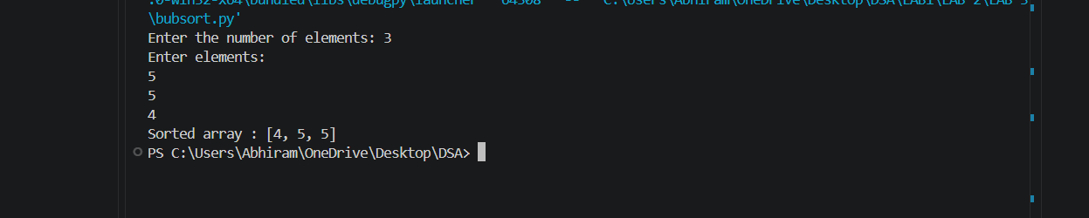
Output(-Ve Case):
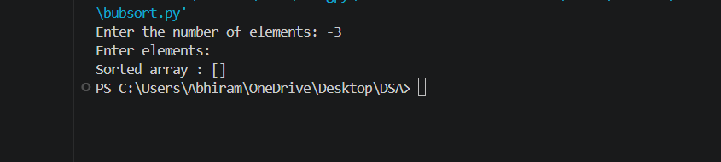
Explanation:
The input values for a given sorting algorithm for an array must never be null hence it throws the error invalid for int() input.
B.) Aim: Write a python program to apply insertion sort where input elements are taken from the user .
Program:
def insertion_sort(arr):
n = len(arr)
for i in range(1,n):
key = arr[i]
j = i-1
while j >= 0 and arr[j] > key:
arr[j+1] = arr[j]
j = j-1
arr[j+1] = key
return arr

n = int(input("Enter the number of elements: "))

arr = []

print("Enter elements:")
for i in range(n):
arr.append(int(input()))

result = insertion_sort(arr)
print(f"Sorted array : {result}")

Output(+Ve Case):
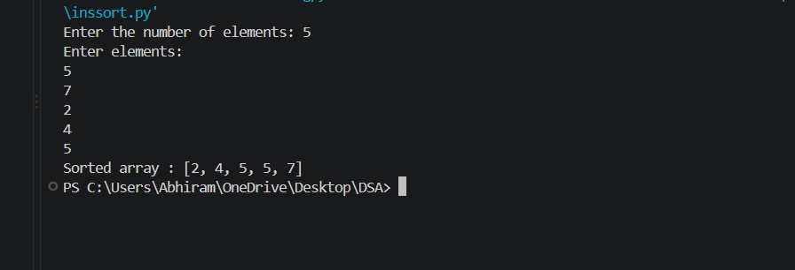
Output(-Ve Case):
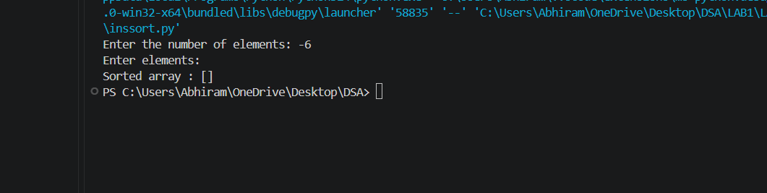
Explanation : The number of input elements should never be negative . In this case since input elements are -10 the program doesn’t allow me to enter any input elements nor is able to sort effeciently.

C.) Aim: Write a python program to apply selection sort where input elements are taken from the user .
Program:
def selection_sort(arr):
n = len(arr)
for i in range(n-1):
min_index = i
for j in range (i+1,n):
if arr[j] < arr[min_index]:
min_index = j
arr[i],arr[min_index] = arr[min_index],arr[i]
return arr

n = int(input("Enter the number of elements: "))

arr = []

print("Enter elements:")
for i in range(n):
arr.append(int(input()))

result = selection_sort(arr)
print(f"Sorted array : {result}")

Output(+Ve Case):
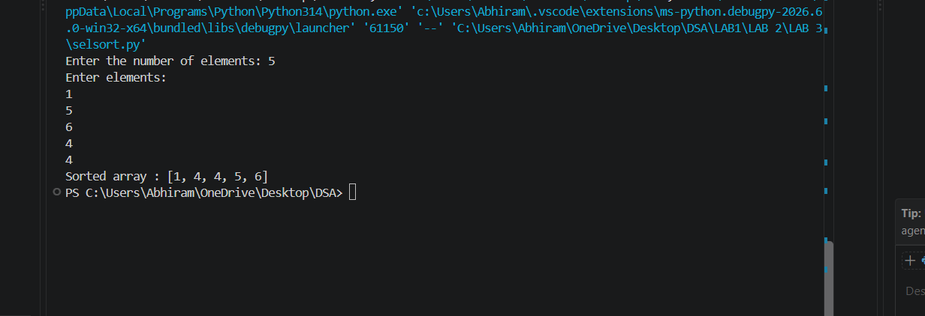

Output(-Ve Case):
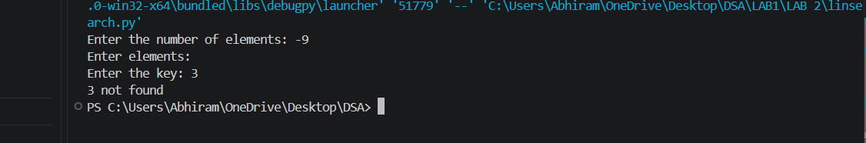
Explanation:
The given Selection Sort accepts only integer values giving values other than the integer data type such as float or special characters or strings results in this type of Value Error.

